35.42: To find destructive interference, 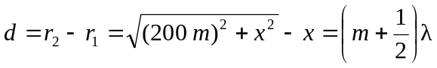 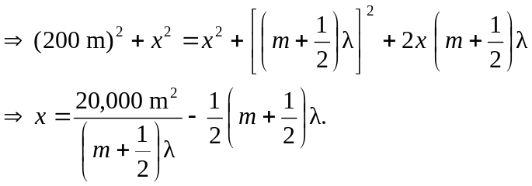
The wavelength is calculated by 